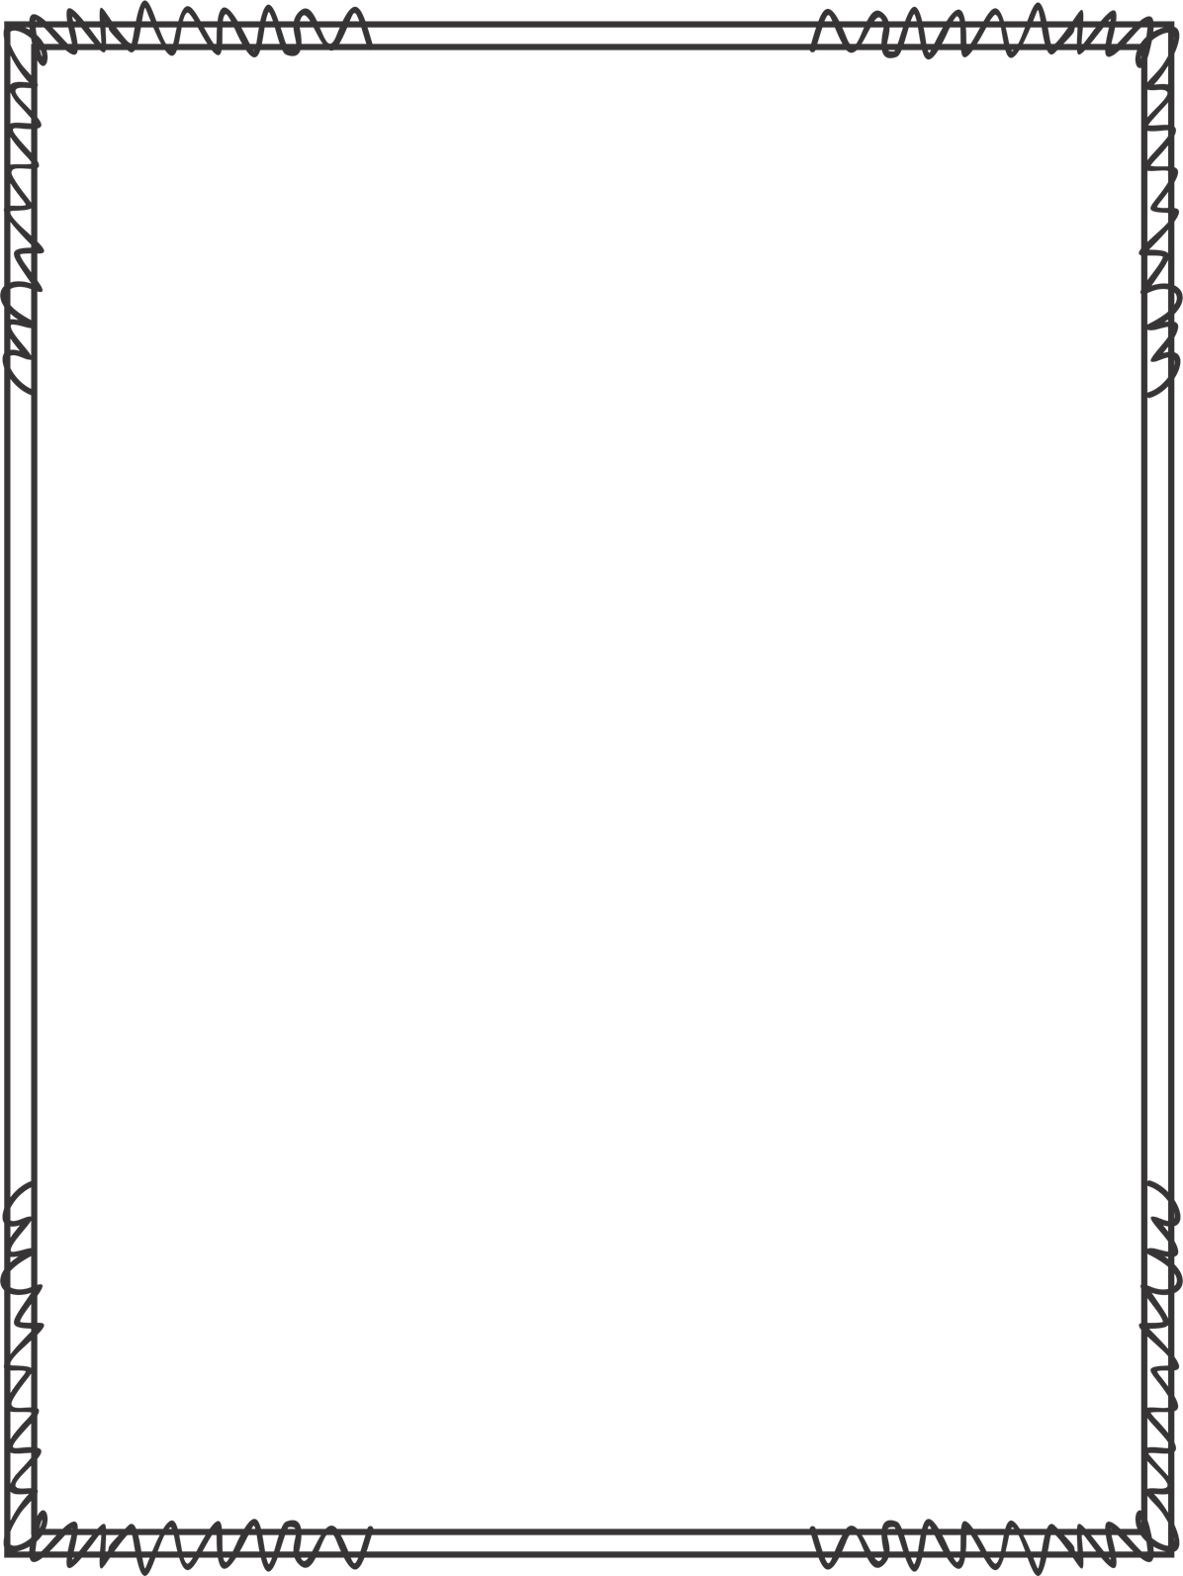
Sensory or Behavior Checklist

Name: |  | Date:
Time of Observation: |  | Location of Observation:
Observer/Title:

Describe the overall behavioral outcome, episode or concern:

Describe what was occurring immediately before the undesired outcome:

Describe the child’s reactions during the undesired outcome:

Describe any adult or peer reactions:

List the sensory characteristics of the  activity or skill |  | List the sensory characteristics of the environment
- tactile | - smell | - loud
- proprioceptive | - taste | - distracting
- vestibular |  | - small space
- visual |  | - large space
- auditory |  | - quiet
List any successful strategies that helped the child:

Overall assessment:

ACTION PLAN:

